Author Centre: Manuscript status

Once you have submitted a manuscript you will be able to track the general progress and see updates of the current status from your author centre dashboard. This journal has recently updated so that more stages of the peer review and submission process are available to view. Login to the relevant S1M site and select ‘author centre’ as shown in the example screenshot below.

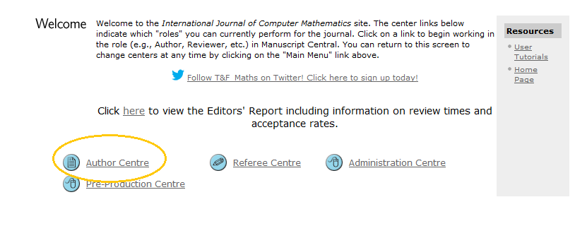

Within the author centre dashboard you will see a list on the left hand side of all the manuscripts that you are currently working. To see the current status of your submitted manuscripts click on the link for’ Submitted Manuscripts’ and then scroll toward the foot of the screen.

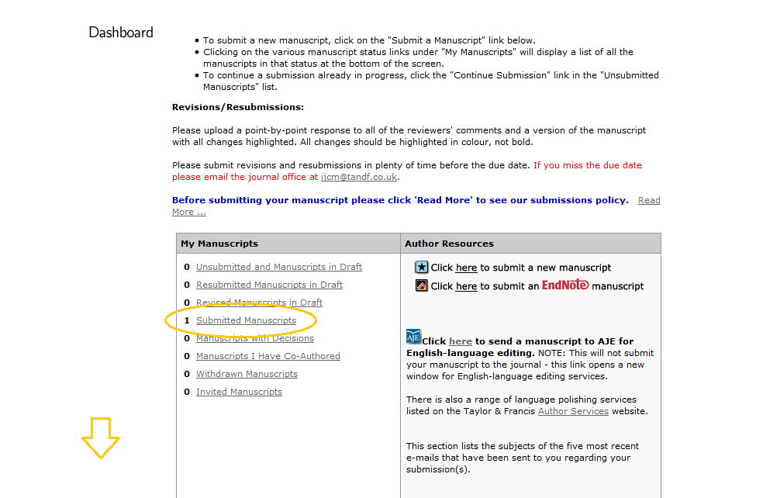

The foot of the screen will show all papers you have submitted to the relevant journal; the Manuscript ID, title, date submitted and current status. At any point during the process, should you wish to receive an update as to what stage your manuscript has reached, please follow these steps to receive the information.

